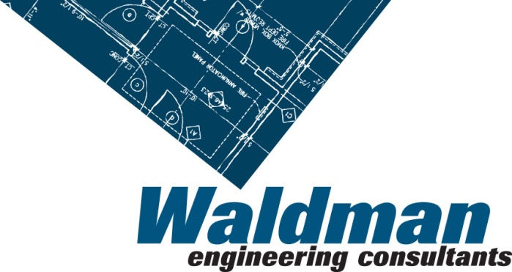

Waldman Engineering would like to offer sincere congratulations to our engineer, Lee N. Smith, on completing and passing his Professional Engineering (PE) exam. We are so proud of Lee and happy to see his hard work being rewarded.
Lee Smith is a graduate of Western Illinois University, and completed his MS degree in Structural Engineering at Bradley University. His expertise on technical support and specification development on structural issues has been invaluable in his time with WEC. Thank you, Lee for continuing to grow and develop alongside our brand.

