Hail Storm Roof Damage:
Understanding the entire Roof System and Project Scope.
According to the Annual Severe Weather Report Summary, produced by NOAA’s National Weather Service, Illinois experienced 210 hail events in 2017. For the entire U.S. that year, hail resulted in $1.6 Billion in property damage.

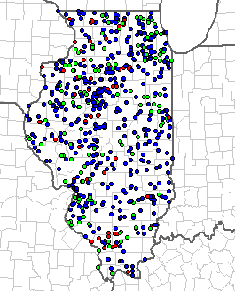
Map from NOAA- Reported hail events are shown in green.

With the number and frequency of hail events, Community Associations often find themselves having to contend with hail damage claims and managing a necessary roof replacement project. After a storm, the sense of urgency should not push the Board of Directors to make a decision without understanding all of the factors that need to be considered when preparing for a roof replacement project. While it is likely that a storm event necessitates a more accelerated project schedule, it is important that critical components and details for the project are not neglected.
An insurance adjuster will analyze the extent of damage to the buildings and outline all of the components that need to be replaced and the associated replacement costs, but it is important for the Association to understand that this is not equivalent to a repair specification. While it may be tempting to trust that the insurance adjuster has identified all aspects of the roof that are in need of replacement, this is a step in the process where many Associations take an unnecessary risk by assuming that a contractor can simply use the report from the insurance company to properly bid the repair project. It is critical to consider the many aspects of a given roof system, such as attic ventilation balance, downspout and gutter design, soffit and fascia details, flashing details, roof penetrations, and insulation depth and condition, just to name a few. The details and methods of how all of these roof components are replaced needs to be clearly defined in the project scope of work, so the bidding contractors can assemble an accurate and informed bid for the project. Not considering these details can result in higher numbers of leaks reported by owners, greater occurrences of ice damming, and accelerated deterioration of the roof system in general.
Taking the time to do this additional work will result in a roof replacement that is more cost effective, be of higher quality, and have a longer life span.

