CertainTeed Class Action Fiber Cement Siding Settlement: Is Your Association Eligible for $1,000,000?
Becky Weber, CDT
Senior Architectural Consultant
Waldman Engineering Consultants, Inc.

Are any communities you manage experiencing issues with CertainTeed fiber cement siding installed prior to September 30, 2013? If so, you may be eligible for a settlement. A class action lawsuit was filed against CertainTeed and settled for $103.9 million, with an effective settlement date of August 11, 2014. This date is important. Class action settlement members have until six (6) years from the effective settlement date to submit a claim. Waldman Engineering Consultants have submitted three claims on behalf of associations in suburban Illinois and one claim on behalf of a non-profit organization in Kansas. As of today, all four claims received payments. The total payments ranged from $103,000 to $500,000 for a total of over $1,500,000. This is only half of the total amount that these organizations will receive. How do you become a settlement class member? Read on!
Who is a settlement class member? Only settlement class members can submit a claim under the class action settlement. You are a settlement class member if you owned a home or residence on which CertainTeed WeatherboardsTM Fiber Cement Siding, Lap Siding, Vertical Siding, Shapes, Soffit, Porch Ceiling, and 7/16” Trim was installed on or before September 30, 2013. Associations do qualify as a property owner under these criteria. Once you determine that you are a member, you must submit an eligible claim.

In order for a claim to be eligible, the siding must exhibit qualifying damage. Qualifying damage to the siding is caused by a siding defect that is manifested in shrinkage between the ends of the boards in excess of 3/16” or siding exhibiting warping or bowing in excess of 1/2”. In addition, siding with warping or bowing in excess of ½”, field and edge cracking through the board, or delamination are also considered qualifying damage. The requirements for qualifying damage of trim boards are similar. If the damage is evident on over 5% of any elevation of the structure, CertainTeed will cover the cost to replace the material on the entire elevation.

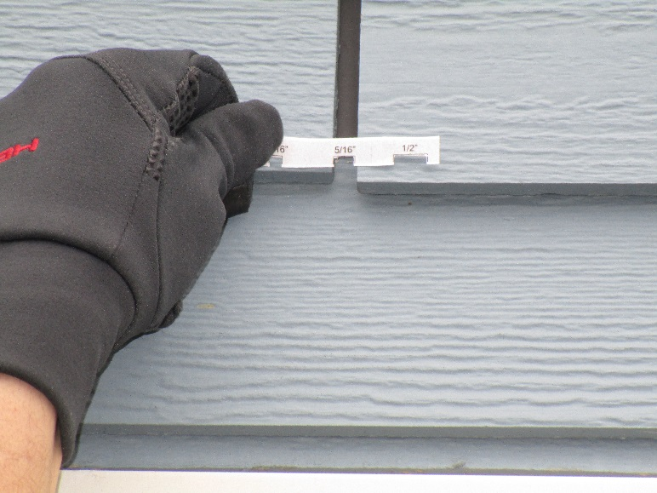
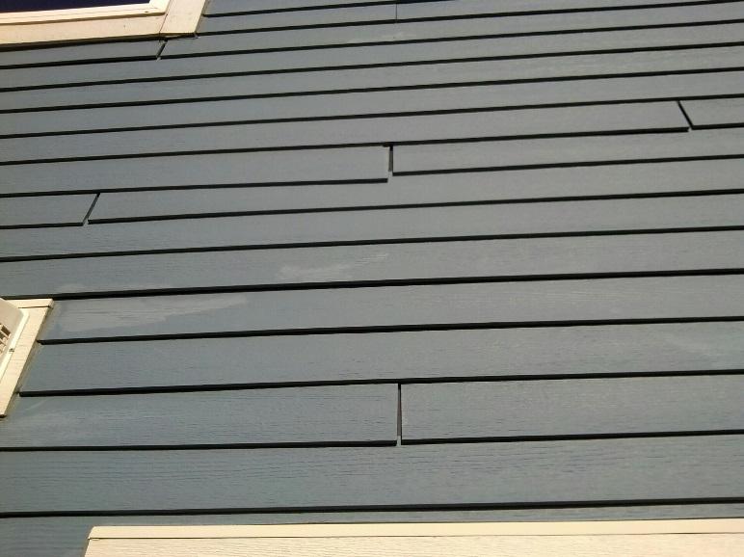
If you are a settlement class member and have qualifying damage on your buildings, a claim needs to be filed by August 11, 2020 to qualify for a financial remedy from CertainTeed. However, there is a fixed settlement pool of $103.9 million, which is paid out as claims are filed. Once the pool is empty, no additional claims will be processed.

How do you file your claim? The claims process is detailed and must be followed to the letter in order for a claim to be submitted. One claim must be submitted per building, with photographic documentation of each elevation where qualified damage exists. Proof of ownership documents, square footage calculations and siding installation details are also required to be submitted.

The submitted claim is reviewed by CertainTeed. If the claim is approved, payments will be made in an amount determined by the cost and installation date of the siding and includes removal and disposal of siding plus the materials and installation of new siding. The payments are made in two installments, half when the claim is approved and half at the end of the settlement period, which is August of 2020. Although most are skeptical that money is ever paid out in a class action settlement such as this, there is proof that CertainTeed is keeping up its end of this deal.

Over the past few years, Waldman Engineering has worked with four different organizations that had defective CertainTeed siding and/or trim. The size of the developments ranged from 17 buildings to 74 buildings. With each client, we were able to conduct siding inspections, confirm that the material was defective and verify that the damage present qualified under the parameters specified for the class action lawsuit.

Waldman Engineering successfully documented the damage and submitted all the required supporting claim documentation for each client. After months of diligent follow-up and conversations between our office and the CertainTeed claims department, all four organization’s claims were approved. The clients received checks that ranged from $103,000 to $500,000. These payments are only the first HALF of the total amount that they will receive! The second installment of their claim will be paid out at the end of the settlement period in August of 2020.

If you think any of your associations may qualify, please contact Becky Weber (630-922-3000 x 102; beckyw@waldmaneng.com) for more information.

